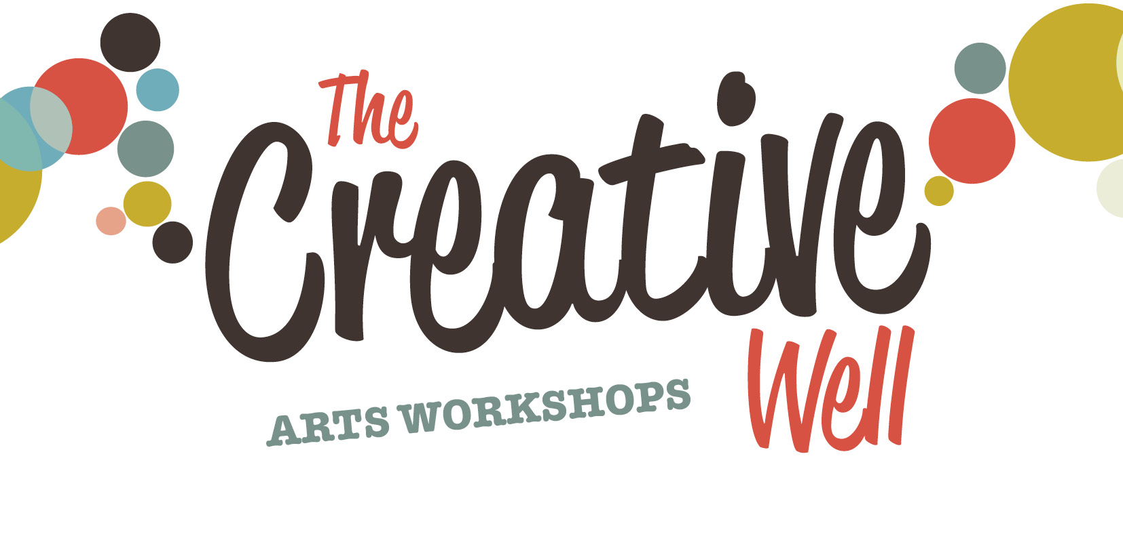

Celbridge Application Form

Name:

Address:

Telephone: Email:

How did you hear about this programme? ….................................................................................
Do you agree to take part in an evaluation of the programme Yes □ No □
Do you give consent for any visual images taken and for their use Yes □ No □
Do you wish to be added to our mailing list to be informed of future programmes Yes □ No □
I am over 18 years of age Yes□ No□

Please outline the reasons why you wish to apply for the Creative Well and how you feel that you would benefit as a result of participating on the programme:

….......................................................................................................................................................
….......................................................................................................................................................
….......................................................................................................................................................
….......................................................................................................................................................
….......................................................................................................................................................
….......................................................................................................................................................
….......................................................................................................................................................
….......................................................................................................................................................
….......................................................................................................................................................
….......................................................................................................................................................

The aim of this programme is to support health and wellbeing through the arts within local communities.

Please note that places are limited, therefore we may not be in a position to offer a place to all applicants. Submitting an application does not guarantee a place on this programme.

The Creative Well is supported by Kildare County Council Arts Service, HSE Kildare West Wicklow Mental Health Services, HSE Health Promotion and Kildare County Mental Health Association.

Closing Date for Applications: Wednesday 06th September 2013

Please return this form to:
Catherine O Grady, Creative Well Programme, St. Marys, Craddockstown Rd, Naas, Co. Kildare

or Email: catherine.ogrady@hse.ie

